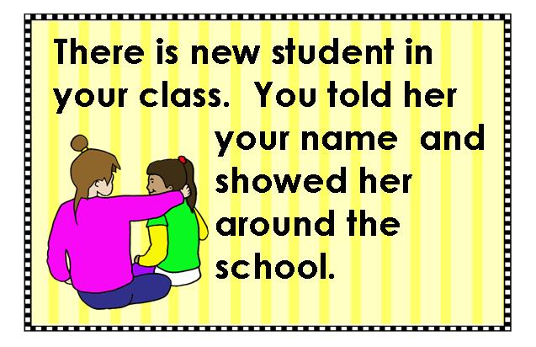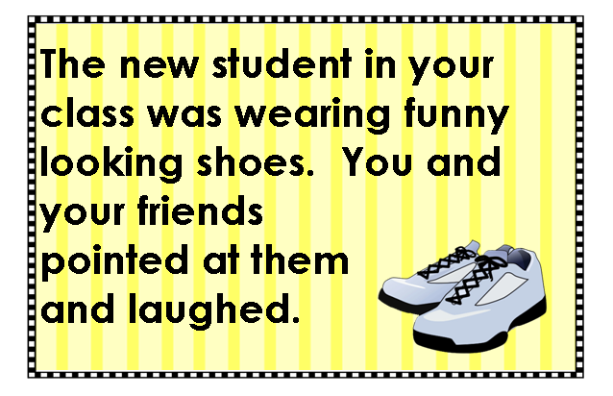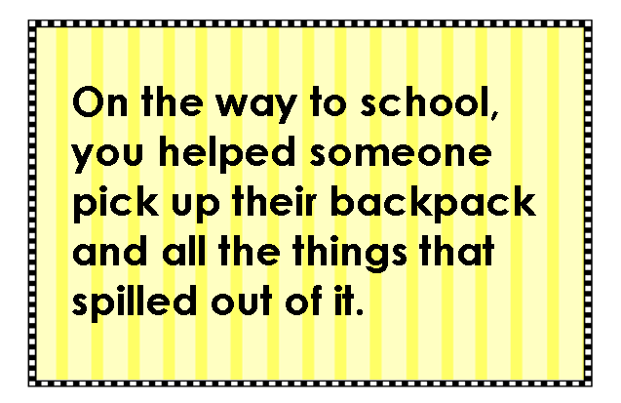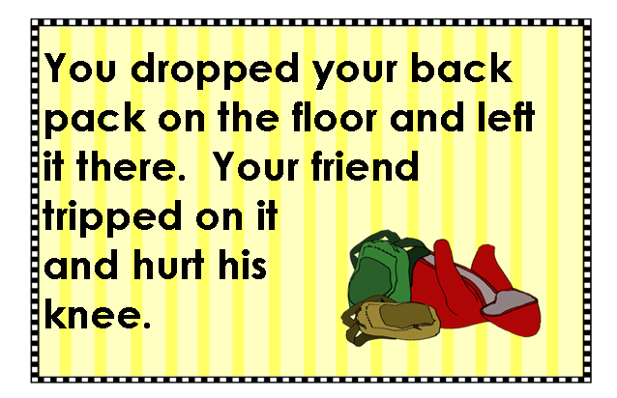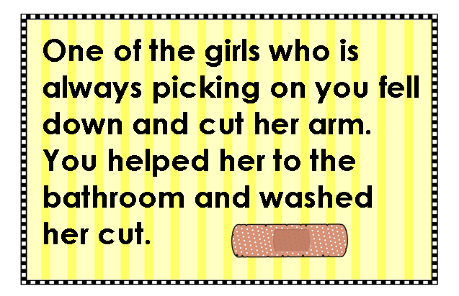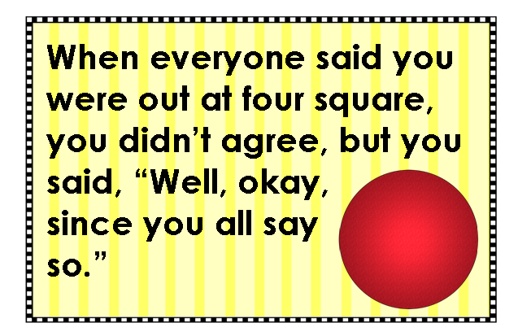
Situation Cards
You can help our class by adding new situations to our collection of situation cards. Just follow the directions below. When all eight cards are completed, I’ll print them out and laminate them. Thanks for making our deck more realistic!

Directions:
1. Choose one card. Double click on the words, “Type your situation here.”
2. Type in a brief description of the situation. Think carefully about the words you choose, because you only have a little space. Everything must fit in the small box, and still be very clear and easy to understand.
3. After you have finished writing your description, notice the color of the icon in the bottom right corner of your card.
4. Scroll down to page 2. Find the box that has the same color icon in the bottom right corner.
5. There are 2 faces in the box. Select the face that is the wrong answer for your scenario. Click on it, and then press Backspace.
6. Click on the correct face. Press the arrow keys to move it into the center of the box.
7. Save the file, and put it away.

Golden Rule: Situation Cards
Copyright © 2013 Integreat! Thematic Units www.thematicteacher.com

Type your situation here.
Type your situation here.
Type your situation here.
Type your situation here.
Type your situation here.
Type your situation here.
Type your situation here.
Type your situation here.



